Sponsorship Scheme  
  
Application Form

Publication date: 23rd September 2025

Deadline for response: 21st October 2025

# Sponsorship Application Form

|  |
| --- |
| 1. Read the most recent [Guide for Applicants](https://www.cnam.ie/app/uploads/2025/09/20250922_Sponsorship-Guide_v.Final_.pdf) published before completing this Application Form. The Guide will inform you of Coimisiún na Meán’s requirements for applying to its Sponsorship Scheme. 2. Complete this Application Form using the order shown in the Contents overleaf. When completed, save as one PDF document. Applications should be submitted to [sponsorship@cnam.ie](mailto:sponsorship@cnam.ie) by 12noon on the 21st October 2025. Coimisiún na Meán will not accept late or incomplete applications. |

**Note:** Please do not complete this form in a web browser. The form must be downloaded and saved before submitting.

# Applicant Details

|  |  |
| --- | --- |
| Name of Applicant: (Organisation/ event/activity) |  |
| Contracting Entity (legally registered name) and legal status: |  |
| Contractor’s Address: |  |
| Contact Person 1 |  |
| Email: |  |
| Phone Number: |  |
| Contact Person 2 *(if applicable):* |  |
| Email: |  |
| Phone Number: |  |
| Event/Organisation Website: |  |
| Social Media handles for event/organisation: |  |

# Event/Activity

## 2.1 Event/Activity Overview

|  |  |
| --- | --- |
| Title of event/Activity |  |
| Date. If dates are not confirmed, please supply indicative dates |  |
| Location(s) |  |
| Describe the eventactivity (max 250 words) |  |
| Set out the proposed format for the event/activity and any agenda details and information regarding proposed speakers / participants. |  |
| Does your proposed event/activity involve minors under the age of 18? |  |
| If yes, is your event/ activity compliant with [Tusla children first guidance and legislation](https://www.tusla.ie/children-first/children-first-guidance-and-legislation/) ? |  |

## 2.2 Strategic Alignment

|  |
| --- |
| This Sponsorship Scheme aims to further Coimisiún na Meán's strategic outcomes, as outlined in its [Strategy Statement 2025-2027](https://www.cnam.ie/app/uploads/2025/04/Coimisiun-na-Mean-Strategy-Statement-2025-2027.pdf) Please outline how your application / proposed event or activity aligns with An Coimisiún's strategic outcomes. Our Vision Our vision is for a thriving, diverse, creative, safe and trusted media landscape. Our Mission We regulate, support and develop a media landscape that underpins fundamental rights and fosters an open, democratic and pluralistic society. Strategic Outcomes  * Irish Culture and Media   A media landscape that is sustainable, pluralistic and participative, and that reflects and shapes who we are as a society.   * Children   A media landscape that upholds the rights, wellbeing and development of children and their safe engagement with content.   * Democracy   A media landscape that supports democracy and democratic values, underpins civic discourse, and reduces the impact of disinformation.   * Diversity and Inclusion   A media landscape that promotes the values of justice, equality, diversity and inclusion.   * Trust   A media landscape that consumers can trust, and where they are protected from exploitation and fraud.   * Public Safety   A media landscape that strengthens public health and safety.  Further detail about each of the above is set out in our Strategy Statement. Please set out below how the proposed sponsorship would reflect An Coimisiún’s vision, and mission, and progress one or more of the strategic outcomes set out in our [**Strategy Statement**](https://www.cnam.ie/app/uploads/2025/04/Coimisiun-na-Mean-Strategy-Statement-2025-2027.pdf) |
| *Type here* |

# Finance

|  |  |
| --- | --- |
| Amount of funding requested |  |
| Total budget for event /activity |  |
| Please complete the budget template provided in Appendix One. (If this is a series of events or activities, please list the total budget amount for each element in the budget template provided) |  |
| If your application is successful, on what will Coimisiún na Meán funding be spent? (please reference line numbers on budget template where possible) |  |
| Please complete the Finance Plan Template provided in Appendix Two. (Outline where the balance of funding for the proposed event/activity is to be sourced and the amount required in the Template Finance Plan) |  |

# Promotion and Recognition

## Should applicants be successful in securing sponsorship, Coimisiún na Meán’s support of the event/activity should be acknowledged, and our up-to-date branding should be used. See example of our current logo below. This branding will be provided to you at the contracting stage and is available at any stage on request.

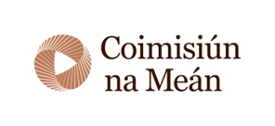

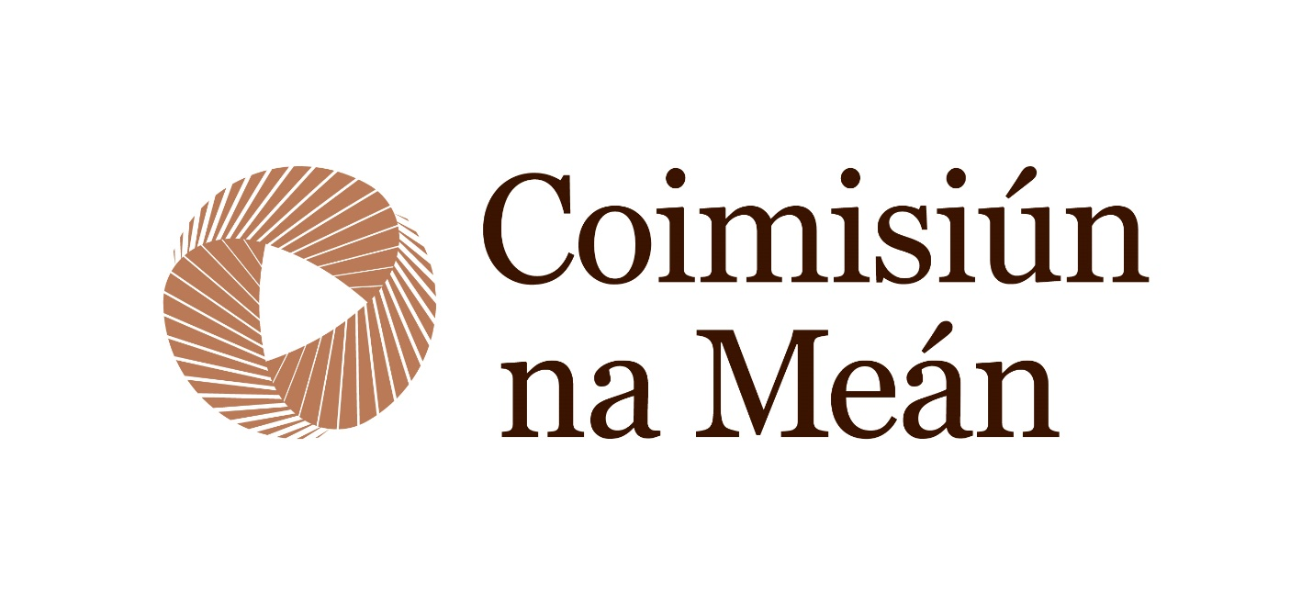

## Outline the marketing strategy for the event / activity and the promotional opportunities Coimisiún na Meán will be afforded through sponsorship, and / or how Coimisiún na Meán’s sponsorship will be recognised, having regard to the following:

|  |
| --- |
| Inclusion of Coimisiún na Meán logo on promotional materials (website, programme, posters / ads) |
| *Indicate Yes / No and provide details* |
| Acknowledgement of Coimisiún na Meán in social media related to the event / activity |
| *Indicate Yes / No and provide details* |
| Coimisiún na Meán support acknowledged in press releases / media announcements |
| *Indicate Yes/No and provide details* |
| Coimisiún na Meán advert in event programme |
| *Indicate Yes / No* |
| Coimisiún na Meán promotional materials (pop-ups, backdrops, videos) used at event |
| *Indicate Yes / No and provide details* |
| If applicable, will there be tickets to the event/ activity and / or speaking opportunities for Coimisiún na Meán |
| *Indicate Yes / No and provide details (specific events/number of tickets etc)* |
| Other |
| *Provide details* |

## Brand Assets

Consider whether you are likely to require any of the below, it is possible to request these during the contracting process

|  |  |
| --- | --- |
| Coimisiún na Mean Brand asset required | Y/N |
| Coimisiún na Meán logo |  |
| Coimisiún na Meán pull up stand |  |
| Coimisiún na Meán promotional video |  |
| Coimisiún na Meán ad for event program |  |

# Track Record

|  |
| --- |
| Describe your experience of organising previous iterations of this event or similar, including any events / activities previously funded by Coimisiún na Meán. Include links where relevant. |
|  |
| The Applicants track record in terms of contracting will also be taken into account. If you have previously entered into a sponsorship contract with Coimisiún na Meán please confirm the contract's status. For example, is the contract closed, or do any required deliverables under the terms of the contract remain outstanding? If the applicant has previously secured funding, please note that Coimisiún na Meán will not enter into a new contract, until all previous contracts are closed. |
|  |

# Declaration

|  |
| --- |
| I have read and understood the relevant Sponsorship Scheme Guideline for Applicants |
| *Please indicate Yes to confirm* |

# Appendix One – Budget Template

|  |  |  |  |  |  |
| --- | --- | --- | --- | --- | --- |
| Project Budget | | | | | |
| Line # | Description | Unit Cost | No. of Units | Total Cost | CnaM contribution |
| 1 |  |  |  |  |  |
| 2 |  |  |  |  |  |
| 3 |  |  |  |  |  |
| 4 |  |  |  |  |  |
| 5 |  |  |  |  |  |
| 6 |  |  |  |  |  |
| 7 |  |  |  |  |  |
| 8 |  |  |  |  |  |
| 9 |  |  |  |  |  |
| 10 |  |  |  |  |  |
| 11 |  |  |  |  |  |
| 12 |  |  |  |  |  |
|  | Total Budget |  |  |  |  |

# Appendix Two – Finance Plan

|  |  |  |  |
| --- | --- | --- | --- |
| Funder | Funding amount € | % of budget | Funding confirmed Y/N |
|  |  |  |  |
|  |  |  |  |
|  |  |  |  |
| Total: |  |  |  |