Media Skills and Development Programme  
  
Application Form

Publication date: 14th October 2025

Deadline for response: 10th November 2025

# Media Skills and Development Application Form

|  |
| --- |
| 1. Read the most recent Guide for Applicants and our [Media Skills and Development Programme Policy](https://www.cnam.ie/app/uploads/2025/10/202501001_MediaSkills_Dev_Policy-ENG.pdf) before completing this Application Form. The Guide and Policy will inform you of Coimisiún na Meán’s requirements for applying to its Media Skills and Development Programme. 2. Complete this Application Form using the order shown in the Contents overleaf. When completed, save as one PDF document. Applications should be submitted to [mediaskillsdev@cnam.ie](mailto:mediaskillsdev@cnam.ie) by 12noon on the 10th November 2025. Coimisiún na Meán will not accept late or incomplete applications. |

**Note:** Please do not complete this form in a web browser. The form must be downloaded and saved before submitting.

# Applicant Details

|  |  |
| --- | --- |
| Name of Applicant Organisation |  |
| Type of Applicant Organisation (for example):   * Representative * Advocacy * Training Body * Educational Institution * Regulated Organisation (individual) |  |
| Proposed Contracting Entity (legally registered name) and legal status: |  |
| Registered Address |  |
| Contact Person 1 |  |
| Email: |  |
| Phone Number: |  |
| Contact Person 2 *(if applicable):* |  |
| Email: |  |
| Phone Number: |  |
| Organisation Website: |  |
| Organisation Social Media handles |  |
| Applicant purpose or role in media sector and specific area the applicant represents. (For example:  community, commercial,  audiovisual) |  |
| How many years has the applicant organisation been in operation? |  |
| How is the applicant primarily funded and what is the annual budget for its activities to date? |  |
| Is this application being made in partnership with another  organisation? If so, name the partner organisation |  |

# Proposed Training and Development Activity / Activities

If more than one activity is planned, please complete the below section for each of the activities concerned. Funding cannot be sought for more than 5 activities.

|  |
| --- |
| **Title of activity 1** |
|  |
| Proposed timeframe within 2026 (start and end date) |
|  |
| Location where the activity will take place. |
|  |
| Description of the training and development activity |
|  |
| Is the proposed activity to be delivered by way of a partnership with another organisation? If so, describe how this partner is involved, for example through funding. |
|  |
| How does the Proposed activity align with our [Strategy Statement 2025-2027](https://www.cnam.ie/app/uploads/2025/04/Coimisiun-na-Mean-Strategy-Statement-2025-2027.pdf) and how does it work to advance one or more of the stated Strategic Outcomes? |
|  |
| How does the Proposed activity meet one or more of the programme specific objectives set out in the [Media Skills and Development Programme Policy](https://www.cnam.ie/app/uploads/2025/10/202501001_MediaSkills_Dev_Policy-ENG.pdf) ? |
|  |
| Proposed Format of Training and / or development activity. |
|  |
| Target Participants |
|  |
| Proposed Trainers / Speakers and confirmation whether these are secured |
|  |
| How do you propose to obtain feedback and measure the impact of the proposed activity? |
|  |
| Does your proposed training or development activity involve minors under the age of 18? If yes, is your training or development activity compliant with [Tusla children first guidance and legislation](https://www.tusla.ie/children-first/children-first-guidance-and-legislation/) ? |
|  |

# Finance Plan

# (Please note no more than 95% of the total budget may be sought)

|  |  |  |  |
| --- | --- | --- | --- |
| **Funder** | **Amount** | **% of Total**  **Budget** | **Confirmed? (Y/N)** |
|  |  |  |  |
|  |  |  |  |
|  |  |  |  |
| **Total** |  |  |  |

# Proposed Budget

If more than one activity is planned, please complete the below section for each of the activities concerned. **Funding cannot be sought for more than 5 activities.**

|  |  |  |  |  |
| --- | --- | --- | --- | --- |
| **Activity #1** | **Funding Request – An Coimisiún** | **Contribution from Applicant** | **Contribution Other Funder** | **Total** |
| Trainer / Speaker |  |  |  |  |
| Venue |  |  |  |  |
| Training Materials |  |  |  |  |
| Accommodation |  |  |  |  |
| Other  (if applicable, give details) |  |  |  |  |
| **Total** |  |  |  |  |

*Insert table for each additional activity as applicable.*

|  |  |  |  |  |
| --- | --- | --- | --- | --- |
| **Overall Operational Costs** | **Funding Request – An Coimisiún** | **Contribution from Applicant** | **Contribution Other Funder** | **Total** |
| Finance and  accounting |  |  |  |  |
| Insurance |  |  |  |  |
| **Overhead**  (no more than  5% of budget) |  |  |  |  |
| **Total** |  |  |  |  |

# State Aid Funding – De Minimus Regulation (EU 2023/2831)

|  |
| --- |
| As noted in the Guide For Applicants An Coimisiún operates this Programme having regard to EU State Aid Rules, and uses the [De Minimus Regulation (EU) 2023/2831](https://eur-lex.europa.eu/eli/reg/2023/2831/oj).Under this regulation, aid granted to one ‘undertaking’ cannot exceed €300,000 in a rolling 3-year period. It should be noted that De Minimis payments to one undertaking under a number of measures or schemes have to cumulatively observe the €300,000 limit.  De Minimis Aid: The current ceiling for all De Minimis aid, regardless of the source of such De Minimis aid, awarded to any single undertaking by any State agency or public body over a three-year period is €300,000. De Minimis aid of up to €300,000 per undertaking over any period of three years is allowed by the European Commission under the De Minimis Regulation as this is considered to be at a level which will not have a substantive effect on trade between Member States nor distort or threaten to distort competition and therefore can be awarded without notification to or clearance by the European Commission.  Applicants must declare to An Coimisiún any De Minimis aid received by them from any public body in the three years before funding is received from An Coimisiún (and any “in progress” applications for state funding). All projects will be checked for De Minimis applicability as part of the initial application and on submission of claims, and this may result in applications being ineligible for grant aid under this Programme. |
| De Minimus Declaration.  Please complete the following declaration. |
| *I wish to apply to the Media Skills and Development Programme for the above-named entity under the De Minimis Regulation (EU) 2023/2831 of 13 December 2023. I confirm that, if the company has been granted any De Minimis aid within the past three years, I will supply all details of this aid.”*  *Please indicate yes to confirm* |
| Please give details of all De Minimis Aid received by your organisation in the three years before funding is received from An Coimisiún. |
|  |

# Promotion and Recognition

## Should applicants be successful in securing funding, Coimisiún na Meán’s support should be acknowledged, and our up-to-date branding should be used where relevant. See example of our current logo below. This branding will be provided to you at the contracting stage and is available at any stage on request.



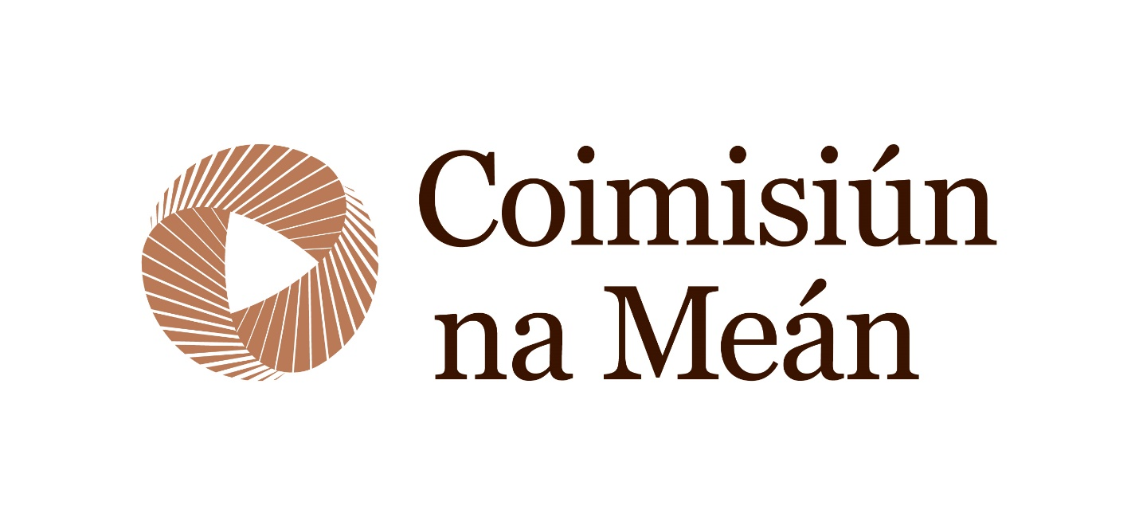

|  |
| --- |
| Explain how any funding support from Coimisiún na Meán will be recognised. |
|  |

# Track Record

|  |
| --- |
| Describe your experience of organising previous training and development activities, including any activities previously funded by Coimisiún na Meán. Include links where relevant. |
|  |
| The Applicants track record in terms of contracting will also be taken into account. If you have previously entered into a contract with Coimisiún na Meán please confirm the contract's status. For example, is the contract closed, or do any required deliverables under the terms of the contract remain outstanding? If the applicant has previously secured funding, please note that Coimisiún na Meán will not enter into a new contract, until all previous contracts are closed. |
|  |

# Guide For Applicants - Declaration

|  |
| --- |
| I have read and understood the relevant Media Skills and Development Programme Guideline for Applicants |
| *Please indicate Yes to confirm* |